 | Air University, Islamabad

Software Requirement Specification
(SRS DOCUMENT)

for
NexAgent
Version 1.0
By
Maarij Bukhari 221803
Syed Muhammad Taha 221787
Abdullah 221837

Supervisor
Dr. Humaira Waqas

Bachelor of Science in Software Engineering (2022-2026)
Revision History
Name | Date | Reason for Changes | Version

Application Evaluation History
Comments (by committee)  *include the ones given at scope time both in doc and presentation | Action Taken

Supervised by
Dr. Humaira Waqas
Signature______________

Table of Contents

1. Introduction 1
1.1 Purpose 1
1.2 Scope 1
1.3 Modules 1
1.4 Overview 1
2. Overall Description 2
2.1 Product Perspective 2
2.2 User classes and characteristics 2
2.3 Operating Environment 2
2.4 Design and Implementation Constraints 2
3. Requirement Identifying Technique 2
4. Functional Requirements 3
5. Non-Functional Requirements 8
5.1 System Performance 8
5.2 System Availability 8
5.3 Scalability 8
5.4 Data Security 8
5.5 Authentication Security 8
5.6 Data Backup and Recovery: 8
5.7 Monitoring & Logging 8
5.8 Usability 9
5.9 Payment Processing Security 9
6. External Interface Requirements 9
6.1 User Interface Requirements 9
6.2 Software Interfaces 9
6.3 Hardware Interfaces 9
6.4 Communication Interfaces 9
7. References 9
8 Appendix A 10
8.1 Context Diagram: 10
8.2 User Classes & Characteristics 11
8.3 Use case Diagram: 12
8.4 Fully Dressed Use Case 13

Introduction
The introduction of the Software Requirements Specification (SRS) should provide an overview of the entire SRS. It should include the purpose, scope, modules and overview of the SRS.

Purpose
NexAgent, a no-code AI workflow automation platform. It is intended for developers, project managers, testers, UI/UX designers, and stakeholders involved in the project. The purpose is to provide a comprehensive guide to understanding the functional and non-functional requirements of the system.

Scope
NexAgent is a web-based software platform that enables non-technical users and small businesses to create AI-driven workflows through an intuitive drag-and-drop interface. It is designed to automate repetitive tasks by integrating with various AI models and external services. NexAgent aims to make AI accessible and usable without programming expertise. Major features include a workflow builder, execution engine, multi-model integration, and usage analytics.

Modules
- User Authentication: Secure login, registration, and session handling.
- Workflow Builder: Visual creation and management of workflows.
- User Management: Role-based access and user impersonation.
- Workflow Execution Engine: Execute, schedule, and monitor workflows.
- Multi-Model Integration: Integration with multiple AI models.
- Canvas Interaction: Live editing and visual data flow on a canvas.

- Usage Analytics: Real-time usage stats and reporting.

- Error Handling & Logging: Workflow error tracking and smart suggestions.
- Settings & Configuration: Preferences, themes, and system limits.

Overview
This SRS provides a structured overview of the NexAgent system. Section 2 discusses the overall system environment. Sections 3 and 4 detail the requirement identification techniques and functional requirements. Sections 5 and 6 cover non-functional and external interface requirements, respectively. Section 7 lists all references.

Overall Description
This section presents a high-level overview of the product and the environment in which it will be used, the anticipated users, and known constraints, assumptions, and dependencies.

Product Perspective
NexAgent is an entirely new product designed to solve the complexity and high costs associated with existing AI automation tools. It stands apart by offering a free, no-code, drag-and-drop interface with powerful AI integrations.

User classes and characteristics
- Non-technical users: Require an intuitive UI and pre-configured logic.
- Small business owners: Need fast setup and cost-effective automation.
- Developers/Advanced users: Interested in API-level access and custom plugin integration.
- Administrators: Manage user access, permissions, and monitor usage.
.

Operating Environment
OE-1: The system shall operate correctly on modern web browsers such as:
- Google Chrome (latest 3 versions)
- Mozilla Firefox (latest 3 versions)
- Microsoft Edge (latest version)
- Safari (latest version)

Design and Implementation Constraints
CON-1: The backend will use Node.js and Python/Flask.
CON-2: The frontend must be developed using Next.js.
CON-3: Firebase and Pinecone will serve as primary databases.
CON-4: OpenAI API will be used for AI model interactions..

Requirement Identifying Technique
The following techniques have been used to identify system requirements:
- Context Diagram – to outline the system’s interaction with external entities.
- Use Case Diagram – to visually represent system functionalities from the user's perspective.
- Fully Dressed Use Cases – to detail user interactions and system behavior for key functionalities.
- User Classes and Characteristics – to define user roles, expectations, and access levels, ensuring the system accommodates diverse user needs.
These techniques helped translate insights from online research and stakeholder feedback into actionable, structured software requirements.

Functional Requirements

Table 1: Description of FR-1
Identifier | FR-1
Title | User Registration and Login
Requirement | The user shall be able to register and log in securely using their credentials. Sessions shall be maintained and expire after a period of inactivity.
Source | User requirements
Rationale | Provides secure access control
Dependencies | None
Priority | High

Table 2: Description of FR-2
Identifier | FR-2
Title | Workflow Creation
Requirement | The user shall be able to create new workflows with a visual interface, defining triggers, actions, and connections between nodes.
Source | User requirements
Rationale | Core functionality for automation design
Dependencies | FR-1
Priority | High

Table 3: Description of FR-3
Identifier | FR-3
Title | Workflow Building
Requirement | The user shall be able to build workflows by dragging and dropping components, configuring parameters, and establishing logical connections between workflow elements.
Source | User requirements
Rationale | Provides intuitive workflow construction interface
Dependencies | FR-2
Priority | High

Table 4: Description of FR-4
Identifier | FR-4
Title | Workflow Execution
Requirement | The system shall execute workflows based on defined triggers and conditions, processing data through the configured sequence of actions.
Source | User requirements
Rationale | Core automation functionality
Dependencies | FR-3
Priority | High

Table 5: Description of FR-5
Identifier | FR-5
Title | User Profile Management
Requirement | The user shall be able to view and edit their profile information, including personal details and account settings.
Source | User requirements
Rationale | Enables user account management
Dependencies | FR-1
Priority | High

Table 6: Description of FR-6
Identifier | FR-6
Title | Activity Log Viewing
Requirement | The user shall be able to view logs of workflow executions, including timestamps, status, and error messages.
Source | User requirements
Rationale | Provides visibility into system operations and debugging capabilities
Dependencies | FR-4
Priority | Medium

Table 7: Description of FR-7
Identifier | FR-7
Title | Usage Analytics
Requirement | The user shall be able to view analytics and metrics about their workflow usage, execution frequency, and performance statistics.
Source | User requirements
Rationale | Enables performance monitoring and optimization
Dependencies | FR-4
Priority | Medium

Table 8: Description of FR-8
Identifier | FR-8
Title | Export Usage Report
Requirement | The user shall be able to export usage reports in various formats (PDF, CSV, Excel) for external analysis and documentation.
Source | User requirements
Rationale | Supports reporting and compliance requirements
Dependencies | FR-7
Priority | Low

Table 9: Description of FR-9
Identifier | FR-9
Title | Error Handling
Requirement | The system shall handle errors gracefully, providing meaningful error messages and recovery options for failed workflow executions.
Source | User requirements
Rationale | Ensures system reliability and user experience
Dependencies | FR-4
Priority | High

Table 10: Description of FR-10
Identifier | FR-10
Title | Marketplace Exploration
Requirement | The user shall be able to browse and explore available workflow templates, integrations, and components in the marketplace.
Source | User requirements
Rationale | Enables discovery of pre-built solutions
Dependencies | FR-1
Priority | Medium

Table 11: Description of FR-11
Identifier | FR-11
Title | Template Purchase
Requirement | The user shall be able to purchase workflow templates and components from the marketplace using integrated payment systems.
Source | Business requirements
Rationale | Supports monetization and premium content access
Dependencies | FR-10
Priority | Medium

Table 12: Description of FR-12
Identifier | FR-12
Title | Custom NexA Listing
Requirement | The user shall be able to list their own custom workflows, templates, or components (NexAs) in the marketplace for others to purchase or use.
Source | Business requirements
Rationale | Enables user-generated content and community contribution
Dependencies | FR-1, FR-10
Priority | Medium

Table 13: Description of FR-13
Identifier | FR-13
Title | Credential Management
Requirement | The user shall be able to securely add, edit, and manage API credentials and authentication tokens for third-party service integrations.
Source | Security requirements
Rationale | Enables secure integration with external services
Dependencies | FR-1
Priority | High

Table 14: Description of FR-14
Identifier | FR-14
Title | Role Assignment (Admin)
Requirement | The admin shall be able to assign roles and permissions to users, controlling access to different system features and capabilities.
Source | Administrative requirements
Rationale | Provides access control and system administration
Dependencies | FR-1
Priority | High

Table 15: Description of FR-15
Identifier | FR-15
Title | Marketplace Management (Admin)
Requirement | The admin shall be able to manage the marketplace, including approving submissions, managing content, and monitoring transactions.
Source | Administrative requirements
Rationale | Ensures marketplace quality and security
Dependencies | FR-10, FR-11, FR-12
Priority | Medium

Non-Functional Requirements

System Performance
The system shall respond to user interactions within 2 seconds for 95% of requests under normal load conditions. Workflow execution shall commence within 5 seconds of trigger activation

System Availability
The system shall maintain 99.5% uptime during business hours (8 AM - 6 PM local time) and 99%
uptime during off-hours, measured monthly.
Source: Business requirements

Scalability
The system shall support up to 10,000 concurrent users and execute up to 100,000 workflows per hour without performance degradation.

Data Security
The system shall encrypt all data in transit using TLS 1.3 and at rest using AES-256 encryption. User credentials and API keys shall be hashed using bcrypt with minimum 12 rounds.

Authentication Security
The system shall implement multi-factor authentication, enforce password complexity requirements (minimum 8 characters with mixed case, numbers, and symbols), and lock accounts after 5 failed login attempts.)

Data Backup and Recovery:
The system shall perform automated daily backups with point-in-time recovery capability. Recovery Time Objective (RTO) shall be less than 4 hours and Recovery Point Objective (RPO) shall be less than 1 hour.

Monitoring & Logging
The system shall log all user actions, workflow executions, and system events with timestamps. Real-
time monitoring shall alert administrators of system issues within 1 minute of occurrence.

Usability
New users shall be able to create and execute their first workflow within 15 minutes of account creation using provided tutorials. The interface shall follow WCAG 2.1 AA accessibility guidelines.

Payment Processing Security
The system shall comply with PCI DSS Level 1 requirements for payment processing. Credit card information shall never be stored on system servers and shall be processed through certified payment gateways only.

External Interface Requirements

User Interface Requirements
- Follows modern responsive design
- Dark/light theme toggle
- Canvas with drag-and-drop, live updates, and error visualization

Software Interfaces
SI-1: Firebase 13.8.0
SI-2: Pinecone (Vector Database)
SI-3: OpenAI API v1.7.0.0

Hardware Interfaces
Not applicable (web-based system)

Communication Interfaces
CI-1: The system shall send real-time status updates and notifications via email or system alerts.

References
- Giorgia Masili. "NO-CODE DEVELOPMENT PLATFORMS: BREAKING THE BOUNDARIES BETWEEN IT AND BUSINESS EXPERTS." Tor Vergata University of Rome, Italy.
- TechTarget.com [accessed May 2025]
- Adalo. "Build Your Own No Code App." (2021)

Appendix A

Context Diagram:

The context diagram in Figure A-1 illustrates the external entities and system interfaces.

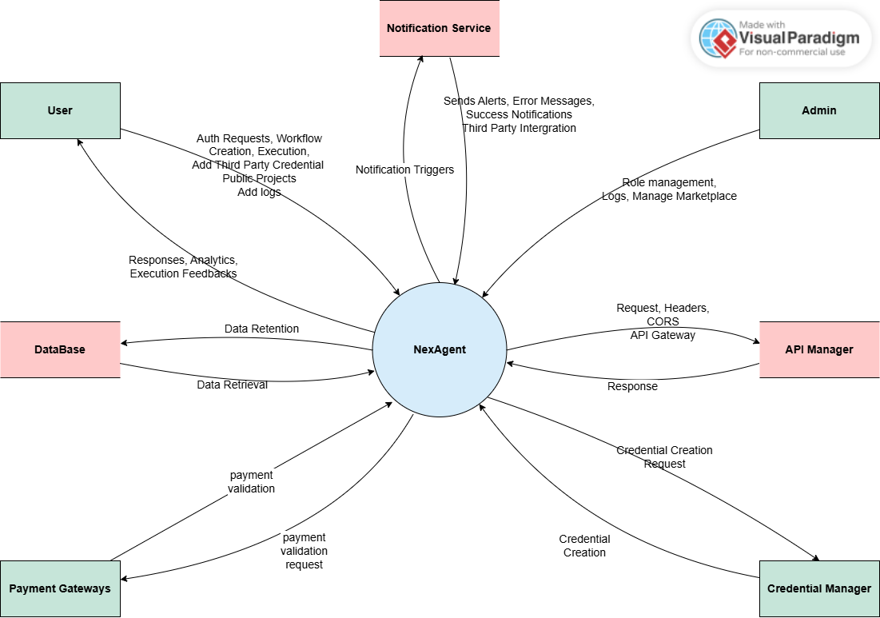

Figure A-1: Context diagram of NexAgent

User Classes & Characteristics

Table A-1 Shows user classes and characteristic for NexAgent
User class | Description
Non-Technical Users | These are individuals with limited technical knowledge who want to automate simple tasks using a visual interface. They rely heavily on predefined templates and guided workflows rather than building custom agents. Usability, simplicity, and support are key for this group.
Small Business Owners | Entrepreneurs or managers of small-to-medium businesses who want to automate tasks like email marketing, order tracking, or lead follow-ups without hiring developers. They value reliability, ease of setup, and cost-effective solutions tailored to business needs.
Developers / Advance Users | These users are technically proficient and seek deep customization of workflows, integration with APIs, and advanced logic for their automation agents. They often create reusable templates and may contribute to the open-source plugin ecosystem of NexAgent.
Administrator | Admins oversee user management, access control, and system configuration. They handle security roles, audit logs, and ensure smooth functioning across teams. Often part of IT departments, they prioritize security, monitoring, and platform governance.

Use case Diagram:

Following use case diagram is of NexAgent in which all the use case diagram relationships are presented.

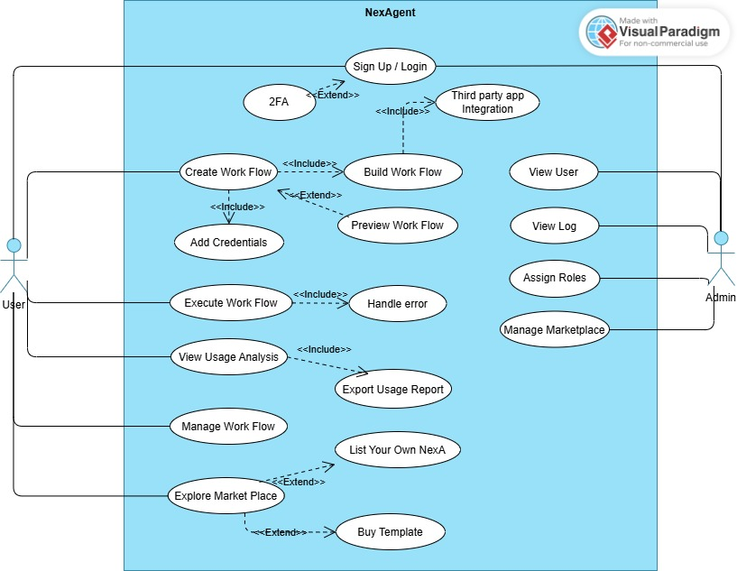

Figure A-2: Use Case Diagram of NexAgent

Fully Dressed Use Case

Table A-2 Show the detail use case for NexAgent
Use Case ID: | UC-01
Use Case Name: | User Registration and Login
Actors: | Primary Actor: User  Secondary Actors: Authentication System
Description: | User registers for a new account or logs into an existing account to access NexAgent functionality.
Trigger: | User clicks on "Sign Up / Login" button from the main interface.
Preconditions: | - PRE-1: User has internet connectivity.  - PRE-2: NexAgent system is operational.
Postconditions: | - POST-1: User is authenticated and session is established.  - POST-2: User is redirected to main dashboard.
Normal Flow: | - User navigates to login/registration page.  - System presents authentication form (login or registration).  - User enters credentials (email/password for login or registration details).  - System validates credentials against database.  - System creates session and generates authentication token.  - System redirects user to main dashboard.
Alternative Flows: | 3.1 New user registration - User fills registration form with email, password, and profile details.  3.2 Forgot password - User clicks forgot password link and enters email for reset.
Exceptions: | 4.0.E1 Invalid credentials - System displays error message and prompts for re-entry.  4.0.E2 Account locked - System informs user about account lockout and recovery options.  5.0.E1 Session creation failure - System displays technical error and asks user to try again.
Business Rules | BR-1: Password must meet complexity requirements (8+ characters, mixed case, numbers, symbols).  BR-2: Account locks after 5 failed login attempts.  BR-3: Sessions expire after 24 hours of inactivity.
Assumptions: | Assume normal system behavior and secure HTTPS connection.

Use Case ID: | UC-02
Use Case Name: | Create Workflow
Actors: | Primary Actor:  User  Secondary Actors:  Workflow Engine
Description: | User creates a new automation workflow using the visual workflow designer interface.
Trigger: | User clicks on "Create Work Flow" button from the main dashboard.
Preconditions: | PRE-1: User is logged in with valid session.  PRE-2: User has appropriate permissions to create workflows.
Postconditions: | POST-1: New workflow is created and saved in the system.  POST-2: Workflow is available in user's workflow list.
Normal Flow: | User initiates workflow creation from dashboard.  System opens workflow designer interface.  User defines workflow name and description.  User selects trigger type and configures trigger parameters.  User adds action nodes and configures their parameters.  User connects nodes to define workflow logic.  System validates workflow configuration.  User saves the workflow.  System stores workflow definition in database.
Alternative Flows: | 3.1 Use template - User selects from available workflow templates instead of creating from scratch.  7.1 Invalid configuration - System highlights errors and prevents saving until corrected.
Exceptions: | 7.0.E1 Validation error - System displays specific validation errors and highlights problematic nodes.  9.0.E1 Save failure - System displays error message and prompts user to try saving again.
Business Rules | 7.0.E1 Validation error - System displays specific validation errors and highlights problematic nodes.  9.0.E1 Save failure - System displays error message and prompts user to try saving again.
Assumptions: | Assume user has basic understanding of workflow concepts and system performance is adequate.

Use Case ID: | UC-03
Use Case Name: | Build Workflow
Actors: | Primary Actor: User  Secondary Actors: Workflow Designer, Component Library
Description: | User builds workflow by adding, configuring, and connecting various workflow components using drag-and-drop interface.
Trigger: | User opens existing workflow for editing or continues building from workflow creation.
Preconditions: | PRE-1: User is logged in with valid session.  PRE-2: Workflow designer interface is loaded.  PRE-3: Component library is accessible.
Postconditions: | POST-1: Workflow components are properly configured and connected.  POST-2: Workflow logic flow is established and validated.
Normal Flow: | User opens workflow builder interface.  System displays available components in sidebar.  User drags components from library to canvas.  User configures component parameters through property panels.  User connects components by drawing connections between input/output ports.  System validates connections and data flow.  User tests individual components or connections.  System provides real-time validation feedback.  User saves workflow configuration.
Alternative Flows: | 3.1 Search components - User searches for specific components using search functionality.  7.1 Test workflow - User runs test execution to verify workflow behavior.
Exceptions: | 6.0.E1 Invalid connection - System prevents invalid connections and shows error message.  7.0.E1 Component test failure - System displays test results and error details.  8.0.E1 Validation failure - System highlights validation errors and provides correction suggestions.
Business Rules | BR-1: Components must be compatible for connection (matching data types).  BR-2: Circular dependencies are not allowed in workflow logic.  BR-3: Each workflow must have defined start and end points.
Assumptions: | Assume user has necessary permissions and component library is up-to-date.

Use Case ID: | UC-04
Use Case Name: | Execute Workflow
Actors: | Primary Actor: System  Secondary Actors: Workflow Engine, External APIs, User
Description: | System executes workflow based on configured triggers and processes data through defined sequence of actions.
Trigger: | Workflow trigger condition is met (scheduled time, webhook, manual execution, etc.).
Preconditions: | PRE-1: Workflow is properly configured and activated.  PRE-2: All required credentials and connections are available.  PRE-3: Workflow engine is operational.
Postconditions: | POST-1: Workflow execution is completed successfully or with documented errors.  POST-2: Execution log is created and stored.  POST-3: Relevant parties are notified of execution status.
Normal Flow: | System detects trigger condition activation.  System validates workflow state and prerequisites.  System initializes workflow execution context.  System processes each workflow step in defined sequence.  System handles data transformation between steps.  System executes external API calls and integrations.  System logs execution progress and results.  System completes workflow and updates status.  System sends completion notifications if configured.
Alternative Flows: | 1.1 Manual execution - User manually triggers workflow execution from interface.  4.1 Conditional branching - System follows different paths based on conditional logic.
Exceptions: | 2.0.E1 Invalid workflow state - System logs error and aborts execution.  4.0.E1 Step execution failure - System applies error handling rules (retry, skip, abort).  6.0.E1 External API failure - System implements retry logic or error handling workflow.  8.0.E1 Completion failure - System logs partial completion and notifies administrators.
Business Rules | BR-1: Failed workflows should implement configured retry policies.  BR-2: Execution timeout limits must be enforced.  BR-3: All executions must be logged for audit purposes.
Assumptions: | Assume external dependencies are generally available and system has adequate resources.

Use Case ID: | UC-05
Use Case Name: | View User Profile
Actors: | Primary Actor: User  Secondary Actors: User Management System
Description: | User views and manages their profile information including personal details and account settings.
Trigger: | User clicks on "View User" option from the main interface.
Preconditions: | PRE-1: User is logged in with valid session.  PRE-2: User profile data is available in system.
Postconditions: | PRE-1: User is logged in with valid session.  PRE-2: User profile data is available in system.
Normal Flow: | User selects view user profile option.  System retrieves user profile data from database.  System displays profile information in organized layout.  User reviews personal information, account settings, and preferences.  User optionally edits profile fields.  System validates any changes made.  User saves profile updates.  System updates database with new information.  System confirms successful update to user.
Alternative Flows: | 5.1 Change password - User navigates to password change section and follows security protocol.  5.2 Update preferences - User modifies notification settings and system preferences.
Exceptions: | 2.0.E1 Profile data retrieval failure - System displays error and prompts user to refresh.  6.0.E1 Validation error - System highlights invalid fields and requests correction.  8.0.E1 Update failure - System displays error message and reverts to previous values.
Business Rules | BR-1: Email address changes require verification.  BR-2: Password changes require current password confirmation.  BR-3: Profile updates are logged for security audit.
Assumptions: | Assume user has legitimate access to modify their own profile information.

Use Case ID: | UC-06
Use Case Name: | View Usage Analytics
Actors: | Primary Actor: User  Secondary Actors: Analytics Engine
Description: | User views analytics and metrics about workflow usage, execution frequency, and performance statistics.
Trigger: | User selects "View Usage Analysis" from the main interface.
Preconditions: | PRE-1: User is logged in with valid session.  PRE-2: User has workflow execution history available.  PRE-3: Analytics data has been processed and is available.
Postconditions: | POST-1: Usage analytics are displayed in visual format.  POST-2: User gains insights into workflow performance and usage patterns.
Normal Flow: | User initiates usage analytics view.  System retrieves analytics data from analytics database.  System processes data and generates visual charts and metrics.  System displays dashboard with key performance indicators.  User reviews workflow execution statistics and trends.  User interacts with charts to drill down into specific metrics.  User optionally adjusts time ranges and filters for analysis.  System updates visualizations based on user selections.
Alternative Flows: | 6.1 Compare workflows - User selects multiple workflows for comparative analysis.  7.1 Custom date range - User sets specific date ranges for focused analysis.
Exceptions: | 2.0.E1 Analytics data unavailable - System displays message about data processing delay.  3.0.E1 Chart generation failure - System falls back to tabular data presentation.
Business Rules | BR-1: Analytics data is updated daily for standard accounts, hourly for premium accounts.  BR-2: Historical data availability depends on user account type and retention policy.  BR-3: Analytics access is limited to workflow owners and authorized users.
Assumptions: | Assume sufficient execution history exists and analytics processing is current.

Use Case ID: | UC-07
Use Case Name: | Export Usage Report
Actors: | Primary Actor: User  Secondary Actors: Report Generation System
Description: | User exports usage reports in various formats for external analysis and documentation purposes.
Trigger: | User clicks "Export Usage Report" from analytics or dashboard interface.
Preconditions: | PRE-1: User is logged in with valid session.  PRE-2: Analytics data is available for export.  PRE-3: User has appropriate permissions for report export.
Postconditions: | POST-1: Usage report is generated in requested format.  POST-2: Report is made available for download or sent to user.
Normal Flow: | User initiates report export from analytics interface.  System presents export options (format, date range, content selection).  User selects desired format (PDF, CSV, Excel) and parameters.  System validates export request and user permissions.  System generates report with selected data and formatting.  System provides download link or email delivery option.  User downloads report or receives via email.  System logs export activity for audit purposes.
Alternative Flows: | 3.1 Scheduled export - User sets up recurring report generation and delivery.  6.1 Email delivery - System sends report directly to user's email address.
Exceptions: | 4.0.E1 Permission denied - System displays access restriction message.  5.0.E1 Report generation failure - System notifies user and suggests trying again later.  6.0.E1 Delivery failure - System provides alternative download option.
Business Rules | BR-1: Report generation may have rate limits based on account type.  BR-2: Exported reports contain only data user is authorized to access.  BR-3: Export activities are logged for security and compliance auditing.
Assumptions: | Assume user has legitimate business need for exported data and adequate system resources.

Use Case ID: | UC-08
Use Case Name: | Handle Error
Actors: | Primary Actor: System  Secondary Actors: Error Handler, User, Administrator
Description: | System handles errors gracefully during workflow execution, providing meaningful error messages and recovery options.
Trigger: | Error condition occurs during workflow execution or system operation.
Preconditions: | PRE-1: System is operational with error handling mechanisms active.  PRE-2: Error detection systems are functioning.
Postconditions: | POST-1: Error is logged and appropriate parties are notified.  POST-2: System attempts recovery or graceful degradation.  POST-3: User receives informative error message with next steps.
Normal Flow: | System detects error condition during operation.  System captures error context and diagnostic information.  System logs error details with timestamp and affected components.  System determines error severity and impact level.  System applies appropriate error handling strategy (retry, fallback, abort).  System notifies affected users with user-friendly error message.  System alerts administrators if error requires intervention.  System monitors for error resolution and recovery.
Alternative Flows: | 5.1 Automatic retry - System attempts automatic retry with exponential backoff.  5.2 Fallback mode - System switches to alternative processing method.  5.3 Graceful degradation - System continues with limited functionality.
Exceptions: | 1.0.E1 Error detection failure - System fails silently, requiring external monitoring detection.  6.0.E1 Notification failure - System cannot notify users, creates internal alert.
Business Rules | BR-1: Critical errors must trigger immediate administrator notification.  BR-2: Error messages to users should be informative but not expose system internals.  BR-3: All errors must be logged with sufficient detail for debugging.
Assumptions: | Assume error handling infrastructure is properly configured and monitoring systems are active.

Use Case ID: | UC-09
Use Case Name: | Explore Marketplace
Actors: | Primary Actor: User  Secondary Actors: Marketplace System, Content Management System
Description: | User browses and explores available workflow templates, integrations, and components in the marketplace.
Trigger: | User clicks "Explore Market Place" from the main interface.
Preconditions: | PRE-1: User is logged in with valid session.  PRE-2: Marketplace content is available and up-to-date.
Postconditions: | POST-1: User can view available marketplace items.  POST-2: User can access detailed information about items of interest.
Normal Flow: | User navigates to marketplace section.  System displays marketplace homepage with featured items and categories.  User browses categories or searches for specific items.  System presents filtered results based on user selection.  User views item details including descriptions, ratings, and previews.  User reads reviews and compatibility information.  User optionally adds items to favorites or wishlist.  System tracks user interactions for personalized recommendations.
Alternative Flows: | 3.1 Search functionality - User uses search bar to find specific templates or components.  5.1 Preview mode - User previews workflow templates before purchase or download.  7.1 Compare items - User compares multiple similar items side by side.
Exceptions: | 2.0.E1 Marketplace unavailable - System displays maintenance message and estimated return time.  4.0.E1 Search results failure - System displays error and suggests browsing categories instead.
Business Rules | BR-1: Marketplace content must be reviewed and approved before publication.  BR-2: User ratings and reviews are moderated for appropriateness.  BR-3: Compatible items are prioritized in search results based on user's system configuration.
Assumptions: | Assume marketplace content is current and user has stable internet connection.

Use Case ID: | UC-10
Use Case Name: | Buy Template
Actors: | Primary Actor: User  Secondary Actors: Payment System, Marketplace System, License Manager
Description: | User purchases workflow templates and components from the marketplace using integrated payment systems.
Trigger: | User clicks "Buy Template" or purchase button for a marketplace item.
Preconditions: | PRE-1: User is logged in with valid session.  PRE-2: User has selected item available for purchase.  PRE-3: Payment system is operational.
Postconditions: | POST-1: Payment is processed successfully.  POST-2: User gains access to purchased item.  POST-3: License is activated and tracked in user's account.
Normal Flow: | User initiates purchase for selected marketplace item.  System displays item details and pricing information.  User reviews purchase details and terms of service.  System redirects to secure payment processing interface.  User enters payment information and billing details.  Payment system processes transaction securely.  System confirms successful payment and activates license.  System adds purchased item to user's library.  System sends purchase confirmation and receipt via email.
Alternative Flows: | 3.1 Free item - System skips payment processing and directly grants access.  5.1 Saved payment method - User selects from previously stored payment methods.  6.1 Payment processing delay - System provides status updates and estimated completion time.
Exceptions: | 6.0.E1 Payment failure - System displays specific error message and suggests resolution steps.  7.0.E1 License activation failure - System provides manual activation option and support contact.  8.0.E1 Library update failure - System ensures user can still access purchased item through alternative means.
Business Rules | BR-1: All payments must be processed through PCI DSS compliant payment gateways.  BR-2: Purchased items are tied to user account and non-transferable unless specified.  BR-3: Refund policy terms are clearly stated before purchase confirmation.
Assumptions: | Assume user has valid payment method and legal authority to make purchase.

Use Case ID: | UC-11
Use Case Name: | Add Credentials
Actors: | Primary Actor: User  Secondary Actors: Credential Management System, Encryption Service
Description: | User securely adds, edits, and manages API credentials and authentication tokens for third-party service integrations.
Trigger: | User clicks "Add Credentials" from settings or integration configuration interface.
Preconditions: | PRE-1: User is logged in with valid session.  PRE-2: User has valid credentials for external service.  PRE-3: Credential management system is operational.
Postconditions: | POST-1: Credentials are securely stored and encrypted.  POST-2: Credentials are available for workflow integrations.  POST-3: Credential access is logged for security audit.
Normal Flow: | User initiates credential addition process.  System presents credential input form with service selection.  User selects service type and enters credential information.  System validates credential format and completeness.  System encrypts credentials using enterprise-grade encryption.  System stores encrypted credentials with access controls.  System tests credential validity with target service (optional).  System confirms successful credential storage.  User can assign descriptive name and usage notes.
Alternative Flows: | 3.1 OAuth integration - System initiates OAuth flow for supported services.  7.1 Credential testing - System performs test connection to validate credentials.  9.1 Credential sharing - User optionally shares credentials with team members (enterprise accounts).
Exceptions: | 4.0.E1 Invalid format - System displays format requirements and examples.  5.0.E1 Encryption failure - System reports security error and prevents storage.  7.0.E1 Test connection failure - System warns user but allows storage if user confirms.
Business Rules | BR-1: All credentials must be encrypted at rest using AES-256 encryption.  BR-2: Credential access requires user authentication and authorization.  BR-3: Credential usage and access attempts are logged for security monitoring.
Assumptions: | Assume user has valid payment method and legal authority to make purchase.
Use Case ID: | UC-12
Use Case Name: | Assign Roles (Admin)
Actors: | Primary Actor: Administrator  Secondary Actors: User Management System, Permission System
Description: | Administrator assigns roles and permissions to users, controlling access to different system features and capabilities.
Trigger: | Administrator selects "Assign roles" from admin interface or user management panel.
Preconditions: | PRE-1: Administrator is logged in with administrative privileges.  PRE-2: Target user account exists in the system.  PRE-3: Role and permission system is operational.
Postconditions: | POST-1: User roles and permissions are updated in the system.  POST-2: User's access capabilities are modified according to new roles.  POST-3: Role assignment is logged for audit purposes.
Normal Flow: | Administrator accesses user management interface.  Administrator searches for and selects target user.  System displays current user roles and permissions.  Administrator modifies roles using role assignment interface.  System validates role combinations and permission conflicts.  Administrator confirms role assignment changes.  System updates user permissions in database. • System notifies user of role changes (optional).  System logs administrative action with timestamp and details.
Alternative Flows: | 2.1 Bulk role assignment - Administrator selects multiple users for batch role assignment.  4.1 Custom permissions - Administrator sets granular permissions beyond standard roles.  8.1 Immediate effect - System immediately applies new permissions without requiring user re-login.
Exceptions: | 5.0.E1 Permission conflict - System prevents conflicting role assignments and suggests resolution.  7.0.E1 Database update failure - System rolls back changes and notifies administrator.  8.0.E1 Notification failure - System logs failure but completes role assignment.
Business Rules | BR-1: Only administrators can assign administrative roles to other users.  BR-2: Role changes must be logged with administrator identity and timestamp.  BR-3: Users must be notified of significant permission changes affecting their access.
Assumptions: | Assume administrator has legitimate authority to modify user roles and understands permission implications.

Use Case ID: | UC-13
Use Case Name: | Manage Marketplace (Admin)
Actors: | Primary Actor: Administrator  Secondary Actors: Marketplace System, Content Management System, Payment System
Description: | Administrator manages the marketplace including approving submissions, managing content, and monitoring transactions.
Trigger: | Administrator accesses "Manage Marketplace" from administrative dashboard.
Preconditions: | PRE-1: Administrator is logged in with marketplace management privileges.  PRE-2: Marketplace system is operational with pending items or transactions.
Postconditions: | POST-1: Marketplace content is reviewed and updated according to administrator actions.  POST-2: Marketplace operations continue smoothly with proper oversight.  POST-3: Administrative actions are logged for audit and compliance.
Normal Flow: | Administrator accesses marketplace management dashboard.  System displays pending submissions, reported content, and transaction summaries.  Administrator reviews pending marketplace submissions.  Administrator approves, rejects, or requests modifications for submissions.  Administrator monitors marketplace transactions and user feedback.  Administrator addresses reported content or policy violations.  Administrator updates marketplace policies and featured content.  System applies administrator decisions and updates marketplace.  System notifies affected users of decisions and policy changes.
Alternative Flows: | 4.1 Conditional approval - Administrator approves with specific requirements or modifications.  6.1 Content removal - Administrator removes violating content and notifies submitter.  7.1 Policy updates - Administrator publishes new marketplace policies and guidelines.
Exceptions: | 3.0.E1 Review queue failure - System displays error and provides alternative access to pending items.  8.0.E1 Update failure - System provides error details and allows retry of administrative actions.  9.0.E1 Notification failure - System logs notification failure for manual follow-up.
Business Rules | BR-1: All marketplace submissions must be reviewed within defined SLA timeframes.  BR-2: Content removal requires documented reason and user notification.  BR-3: Policy changes must be communicated to all marketplace participants.
Assumptions: | Assume administrator has adequate knowledge of marketplace policies and legal/compliance requirements.

Use Case ID: | UC-14
Use Case Name: | Third-Party App Integration
Actors: | Primary Actor: System  Secondary Actors: Third-Party API Provider (e.g., Google, LinkedIn, Slack), User, Workflow Engine
Description: | The system connects and integrates with third-party applications via their APIs to send or retrieve data as part of an automated workflow execution.
Trigger: | User initiates a workflow that includes third-party app integration or a scheduled/automated trigger activates the workflow containing integration steps
Preconditions: | PRE-1: Third-party application credentials (e.g., OAuth tokens or API keys) are correctly configured  PRE-2: The integration step is defined and activated in the workflow  PRE-3: Internet connectivity and API endpoints are accessible  PRE-4: Workflow engine is operational
Postconditions: | POST-1: Data is successfully sent to or retrieved from the third-party application  POST-2: Integration step result is stored/logged  POST-3: Any transformation or response is passed to the next step in the workflow  POST-4: User is notified if the step fails or succeeds (if notification is enabled)
Normal Flow: | System loads and validates the workflow that includes third-party integration steps  System retrieves stored credentials for the specified third-party app  System authenticates with the third-party API (e.g., via OAuth 2.0 token).  System constructs the request payload using the data available from previous steps  System sends the API request to the third-party service  System receives the response from the third-party API  System validates and stores the response (or error)  System proceeds to the next step in the workflow  System logs all API interaction metadata (status, duration, payload, etc.)  If configured, system notifies the user of integration success/failure
Alternative Flows: | 1.1 Re-authentication Required: If token is expired, system attempts token refresh before making the request.  4.1 Data Mapping Error: If the data from the previous step cannot be mapped to the expected format, system skips or transforms the data before continuing.  5.1 Retry on Timeout: If the third-party API call times out, system retries based on retry policy (e.g., 3 attempts with exponential backoff).  9.1 Custom Logging: System logs enhanced metadata if the user has enabled detailed logging for third-party integrations.
Exceptions: | 3.0.E1 Authentication Failure: System logs error, notifies the user, and aborts the integration step.  5.0.E1 API Rate Limit Exceeded: System waits for the cooldown period or switches to an alternative integration (if defined).  6.0.E1 Invalid Response Format: System logs the invalid response and either aborts or continues based on the workflow configuration.  7.0.E1 Data Validation Failure: Response data fails schema validation—system logs and optionally triggers fallback logic.

